World-wide melodies
easy arrangements for all organs by Guus Jansen
INDEX:
Adagio Theme – L.v. Beethoven.
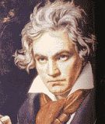L.v. Beethoven
Alla Turca, opus 149 nr. 26 - Diabelli.
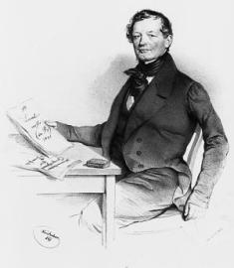 Diabelli
Allegretto , opus 149 nr. 5 – Diabelli
Alouette – French folk song
Amen – Negro Spiritual
American Patrol – F.W. Meacham
Apache Dance – j. Offenbach
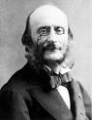J. Offenbach
Arioso – J.S. Bach
Au clair de la lune – French folk song
Ave Maria – Bach-Gounod
Ave Maria – Fr. Schubert
Ave Verum – W.A. Mozart
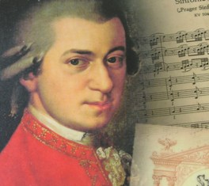Wolfgang Amadeus Mozart
Ay, Ay, Ay – Spanish song
Battle hymn of the republic – J.S. Howe
Berceuse de Jocelyn – B. Godard
Blue bells of Scotland – Scottish song
Boat song – C.M. v. Weber
British Grenadiers, The – English March
Can Can – J. Offenbach
Cantique de Noël - A. Adam
Carnival of Venice – Italian Song
Chanson Triste – P. Tsjaikowsky
Chicken Reel – Scottish song
Choclo, El – A.C. Villoldo
Clarinet Polka – Folk Dance
Clementine – French Song
Cucaracha, La – South American Dance
Cygne. Le – C. Saint Saëns
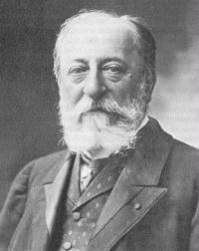C. Saint Saëns
Dances from Tirol – Traditional
Dark Eyes – Russian Folk song
Deep River – Negro spiritual
Dichter un Bauer – Fr. V. Suppé
Do-Do, Te-Do – G. Jansen
Donauwellen – J. Ivanovici
Down by the riverside – Negro spiritual
Down in the valley
Entertainer, The – S. Joplin
Etude op. 10 nr. 3 – Fr. Chopin
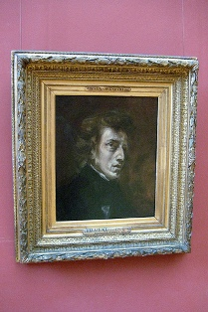Fr. Chopin
Eurovion Tune – M.A. Charpentier
For he’s a jolly good fellow – Home Song
Frysk Folksliet – E.H. Halbertsma
Golondrina, La – N. Sarradel
Greensleeves – English Folk song
Hava Nagila – Hebrew song
Holy City, The – St. Adams
House of the rising sun, The – Traditional
Hungarian Dance nr. 4 – J. Brahms
Iamchtikine goni lochdey – Russian Folk Song
Impromptu nr. 3 – Fr. Schubert
Impromptu nr. 4, Trio – Fr. Schubert
Io vivat – Student Song
Jägerfreuden – Austrian Hunter song
Jeanie with the light brown hair – St. Foster
John Brown’s body – W. Steffe
Joshua fit the battle of Jericho – Negro spiritual
Juhé Tirolerland – Trditional
Kasbek – Caucarion Song
Kol Nidrei – M. Bruch
Lang zal Hij (zij) leven – Dutch Birthday Song
Last Rose of Summer – Van Flotow
Legend of the bell, The – R. Planquette
Little Brown Jug – Traditional
Look down that lonesome road – Traditional
Love’s dream after the ball – A. Czibulka
Mary had a baby – Negro Spirtual
Mary had a little lamb – Children’s Song
Matinata, La – R. Leoncavallo
Moment Musical nr. 3 – Fr. Schubert
Moscow nights – Russian Folk Song
My heart at the sweet voice – C. Saint Saëns
My old Kentucky Home – St. Foster
Nobody knows the trouble I’ve seen – Negro Spirtual
O Haupt voll Blut und Wunden – J.S. Bach
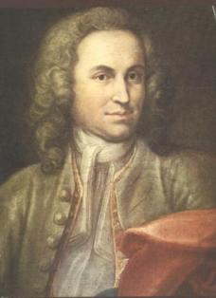J.S. Bach
Old Black Joe – Southern Song
On top of old smokey – Kentucky Mountain Song
Orpheus in the underworld – J. Offenbach
Pogaley – Russian folk song
Polovtsian Dance – A. Borodin
Prosit, Ein – German Drinking Song
Red River Valley – Cowboy Song
Rule Britannia – Dr.Arne
Schenkt man sich Rosen in Tirol – C.Zeller
Scherzo, Opus 149 nr. 6 – Diabelli
Somebody’s knocking at your door – Negro Spirtual
Song of the Volga boatmen – Russian Folk Song
Song my mother taught me – A, Dvorak
Stänchen – Fr. Schubert
Stenka Rasin – Russian Folk Song
Stille Nacht – Fr. Gruber
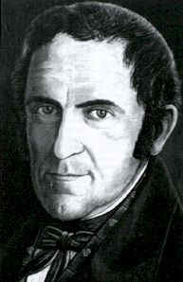Fr. Gruber
Sur le pont d’Avignon – French Folk Song
Symphony Nr. 40 in G minor – W.A. Mozart
W.A. Mozart
Symphony Pathétique – P. Tchaikovsky
Tesoro Mio – E. Becuccu
Theme from the 9th Symphony – L.v. Beethoven
L. v. Beethoven
Tiroler Holzhacker Buab’n - Traditional
Trumpet Voluntary – J. Clark
Two Guitars – Russian Folk Song
Vogelhändler Walzer – C. Zeller
We shall overcome – Negro Spirtual
Yellow Rose of Texas, The – Cowboy Song

