Yehudi Menuhin
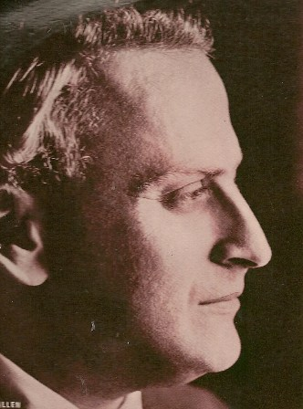
Side 1
Mendelsohn- Concerto in E minor, op. 64
Band 1 First Movement : Allegro molto appassionata
Second Movement: Andante
Band 2 Third Movement: Allegretto non troppo, Allegro molto vivace
Side 2
Band 1 Beethoven: Romance Nr. 1 in G major, op. 40
Band 2 Beethoven: Romance Nr. 2 in F major, op. 50
Romances 1 & 2 with the Philharmonia Orchester o.l.v. Wilhelm Furtwängler

