20 Country Hits
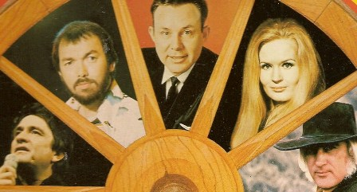
Side 1
1 Ring of Fire (Johnny Cash)
2 Just want to taste your wine (Billy Swan)
3 High Noon (Do not forsake me) (Frankie Laine)
4 The most beautiful girl (Charly Rich)
5 Green, Green ( The new Christy Minstrels)
6 Colinda ( Lucille Starr)
7 Together again (Flying Burrito Bros)
8 There goes my everything (Summerset)
9 My dear rose ( Albert West)
10 Mr. Tambourine (The Byrds)
Side 2
1 Me and Bobby McGee ( Tumbleweeds)
2 You’re My Man (Lynn Anderson)
3 Cool Water ( Marty Robbins)
4 Am I that easy to forget (Skeeter Davis)
5 Distant Drums (Jim Reeves)
6 Goodnight Irene (Leon Russell)
7 Give My Love To Rose (Johnny Cash and June Carter)
8 Before the next teardrops fall (Freddy Fender)
9 Still Feeling Blue (Country Gazette)
10 Stand By Your Man (Tammy Wynette)

