THE LOVE ALBUM
James Last
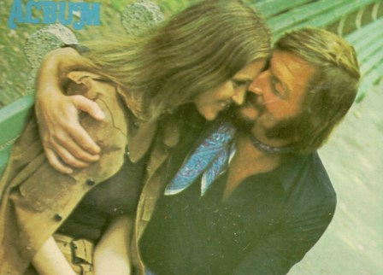
Side One:
Theme from ‘Love Story’
Games that Lovers Play
This is my song
Lara’s theme
What now my love
Guantanamera
Side Two:
Aquarius
Mr. Tambourine Man
Elizabethan Serenade
You’ve lost that lovin’ feeling
I got you babe

