ABBA/ARRIVEL
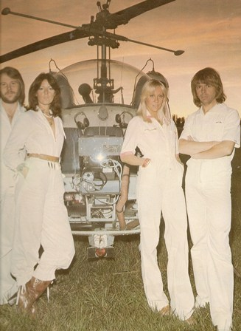
Side A:
1 When I kissed the teacher
2 Dancing Queen
3 My love, My life
4 Dum Dum Diddle
5 Knowing me, knowing you
Side B:
1 Money, Money, Money
2 That’s me
3 Why did it have to be me
4 Tiger
5 Arrivel
1976

