Daddy was a railroad man
Boxcar Willy
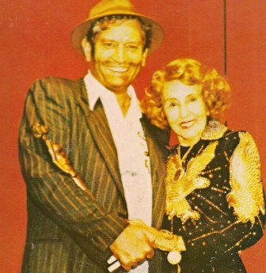

Side 1
1 My daddy was a railroad man
2 Papa’s old pocket watch
3 I love the sound of a whistle
4 Hot box blues
5 Rusty guitar strings
Side 2
1 I’m getting’ out while I’m still country
2 The day Elvis died
3 Country music nightmare
4 I’m going back to Texas
5 She just won ‘t stop loving me

