Louis Armstrong
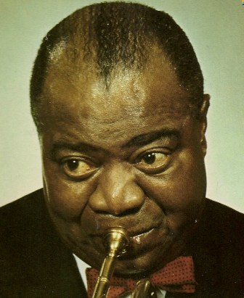
20 greatest hits vo. 2
Side 1
1 Jeepers creepers
2 Do you know what it means to miss New Orleans
3 That’s a plenty
4 Undecided
5 Indiana
6 Black and Blue
7 Ole Miss
8 A Monday date
9 West and Blues
10 Savoy Blues
Side 2
1 Tin roof blues
2 Ain’t misbehavin’
3 You can depend on me
4 Back o’ town blues
5 Tiger Rag
6 I’m confessin’ that I lover You
7 Struttin’ with some barbecue
8 Up the lazy river
9 Dippermouth blues (Suger foot stomp)
10 The flat foot floogie

