‘Never Forgotten’
Louis Armstrong
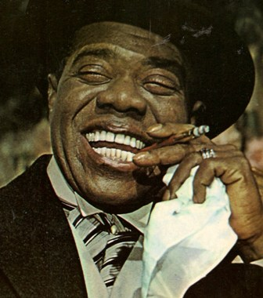
Side 1
1 Sweet sue – Just You
2 St. Louis Blues
3 I’ve got the world on a string
4 Honey, do !
5 Swing you Cats
6 Mighty River
Side 2
1 Do you know what it means to miss New Orleans
2 Jack – Armstrong Blues
3 I wonder, I wonder, I wonder
4 Before Long
5 Where the blues were born in New Orleans
6 It takes time

