Piano à gogo
James Last
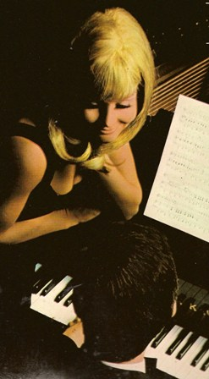
. Java
. My Bonny
. Maria
. Happy Days Are Here Again
. Lingering On
. Mack the Knife
. Everbody Loves A Lover
. My Guy’s Come Back
. Mexico City
. Poème
. Love Me Or Leave Me
. Bei mir bist du schön
. The House Of The Rising Sun
. America

