Love Must be the Reason
James Last
Orchestra and Chorus
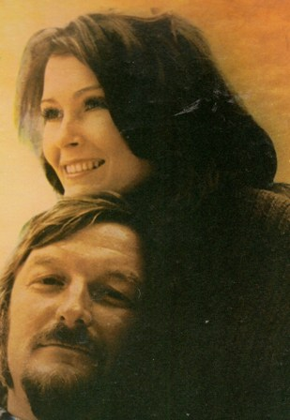
Side one:
1 Wedding Song
2 It’s going to take some time
3 Speak softly love
4 Close to You
5 The summer knows
6 Heart of Gold
Side two:
1 Wthout you
2 Face in a crowd
3 The way of love
4 I don’t know how to love him
5 Love must be a reason
1972

