Marty
speelt de hits van Herb Alpert, Al Hirt, Harry James, James Last, Nini Rosso, Willy Schobben en Marty.
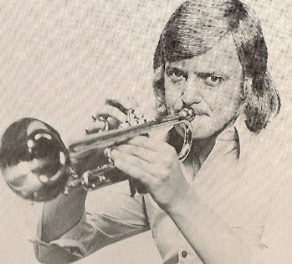
Kant 1
1 O, mein Papa
2 Laura’s thema from Dr. Zhivago
3 Cherry Pink an apple blossom white.
4 What a wonderful world
5 Maanserenade
6 Tennessee waltz
Kant 2
1 Il selenzio
2 A banda
3 Alma mia
4 Ajax wint de wereldcup (Lapland)
5 Elvira Madigan
6 Trompet Polka

