Festival
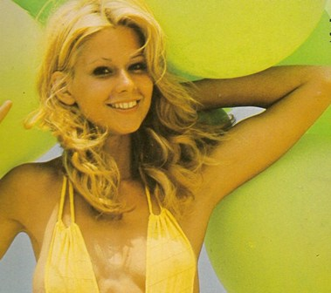

Kant 1
1 Sothern Nights (Roberto Delgado)
2 Beautiful Rose ( Max Greger)
3 That’s amore (Johnny Vick)
4 El Negrito Del Batey (Tony Bas)
5 Smile (Robert Delgado)
6 Island In The Sum (Bert Kaempfert)
Kant 2
1 a Tanze Samba mit mir (Max Greger)
b Ma Baker (Max Greger)
2 Isn’t She Lovely ( Jorgen Ingmann)
3 Angelina (Herman Schoonderwalt)
4 Ela-Ela (Roberto Delgado)
5 Diamonds Are Forever (John Barry)
6 The Odenin Line Theme (David Rose)

