ACCORDING TO MY HEART
Jim Reeves
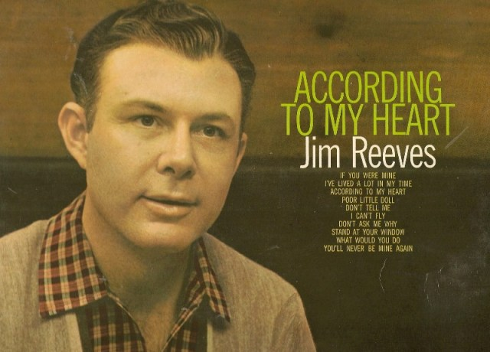
Side 1
According to my heart
Don’t you want to be a girl
Don’t tell me
You’ll never be mine again
I’ve lived a lot in my time
Side 2
If you were mine
Don’t ask me why
Stand at your window
What would you do ?
I can’t fly

